General information for the employees

The prevention advisor psychosocial aspects (PAPSY) has a personal consultation with the employee.
The petitioner can then choose between an informal or a formal procedure considering reducing or removing the psychosocial risk which he believes to encounter at work.

Request for informal psychosocial intervention
- The CC/PAPSY listens and gives advice in full confidentiality.

- Helps to search for a solution and can for this purpose do an intervention with a third party within the organisation (for example supervisor, HR,…).

- Organizes a mediation between involved parties (the agreement of both parties is necessary).

Request for a formal psychosocial intervention (only possible with the PAPSY)

It is mandatory to organize a personal consultation with the prevention advisor psychosocial aspects within a term of 10 calendar days from the moment the employee expresses his wish to request a formal intervention.

The request for a formal psychosocial intervention will be committed in a document that is drafted, dated and signed by the petitioner. This document will be handed over personally or by recorded delivery to the prevention advisor psychosocial aspects.

The prevention advisor psychosocial aspects has the authority to refuse the request when it is not related to psychosocial risks at work.

The prevention advisor psychosocial aspects determines whether the request for a formal intervention for psychosocial risks at work entails individual risks or collective risks.

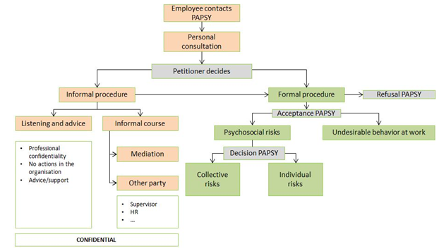

PREPARATION CONVERSATION

To prepare the conversation as good as possible, you can already reflect on the following questions.

Description of the difficult situation and consequences
What are the facts you are confronted with and what is the impact of those on your working situation.

Description facts
- …
- …
- …

Description consequences
- …
- …
- …

Previous steps already taken
Initiatives already taken to improve the situation
- …….
- …….
- ……

My expectations
Future initiatives that can improve the situation
- …….
- …….
- …….

